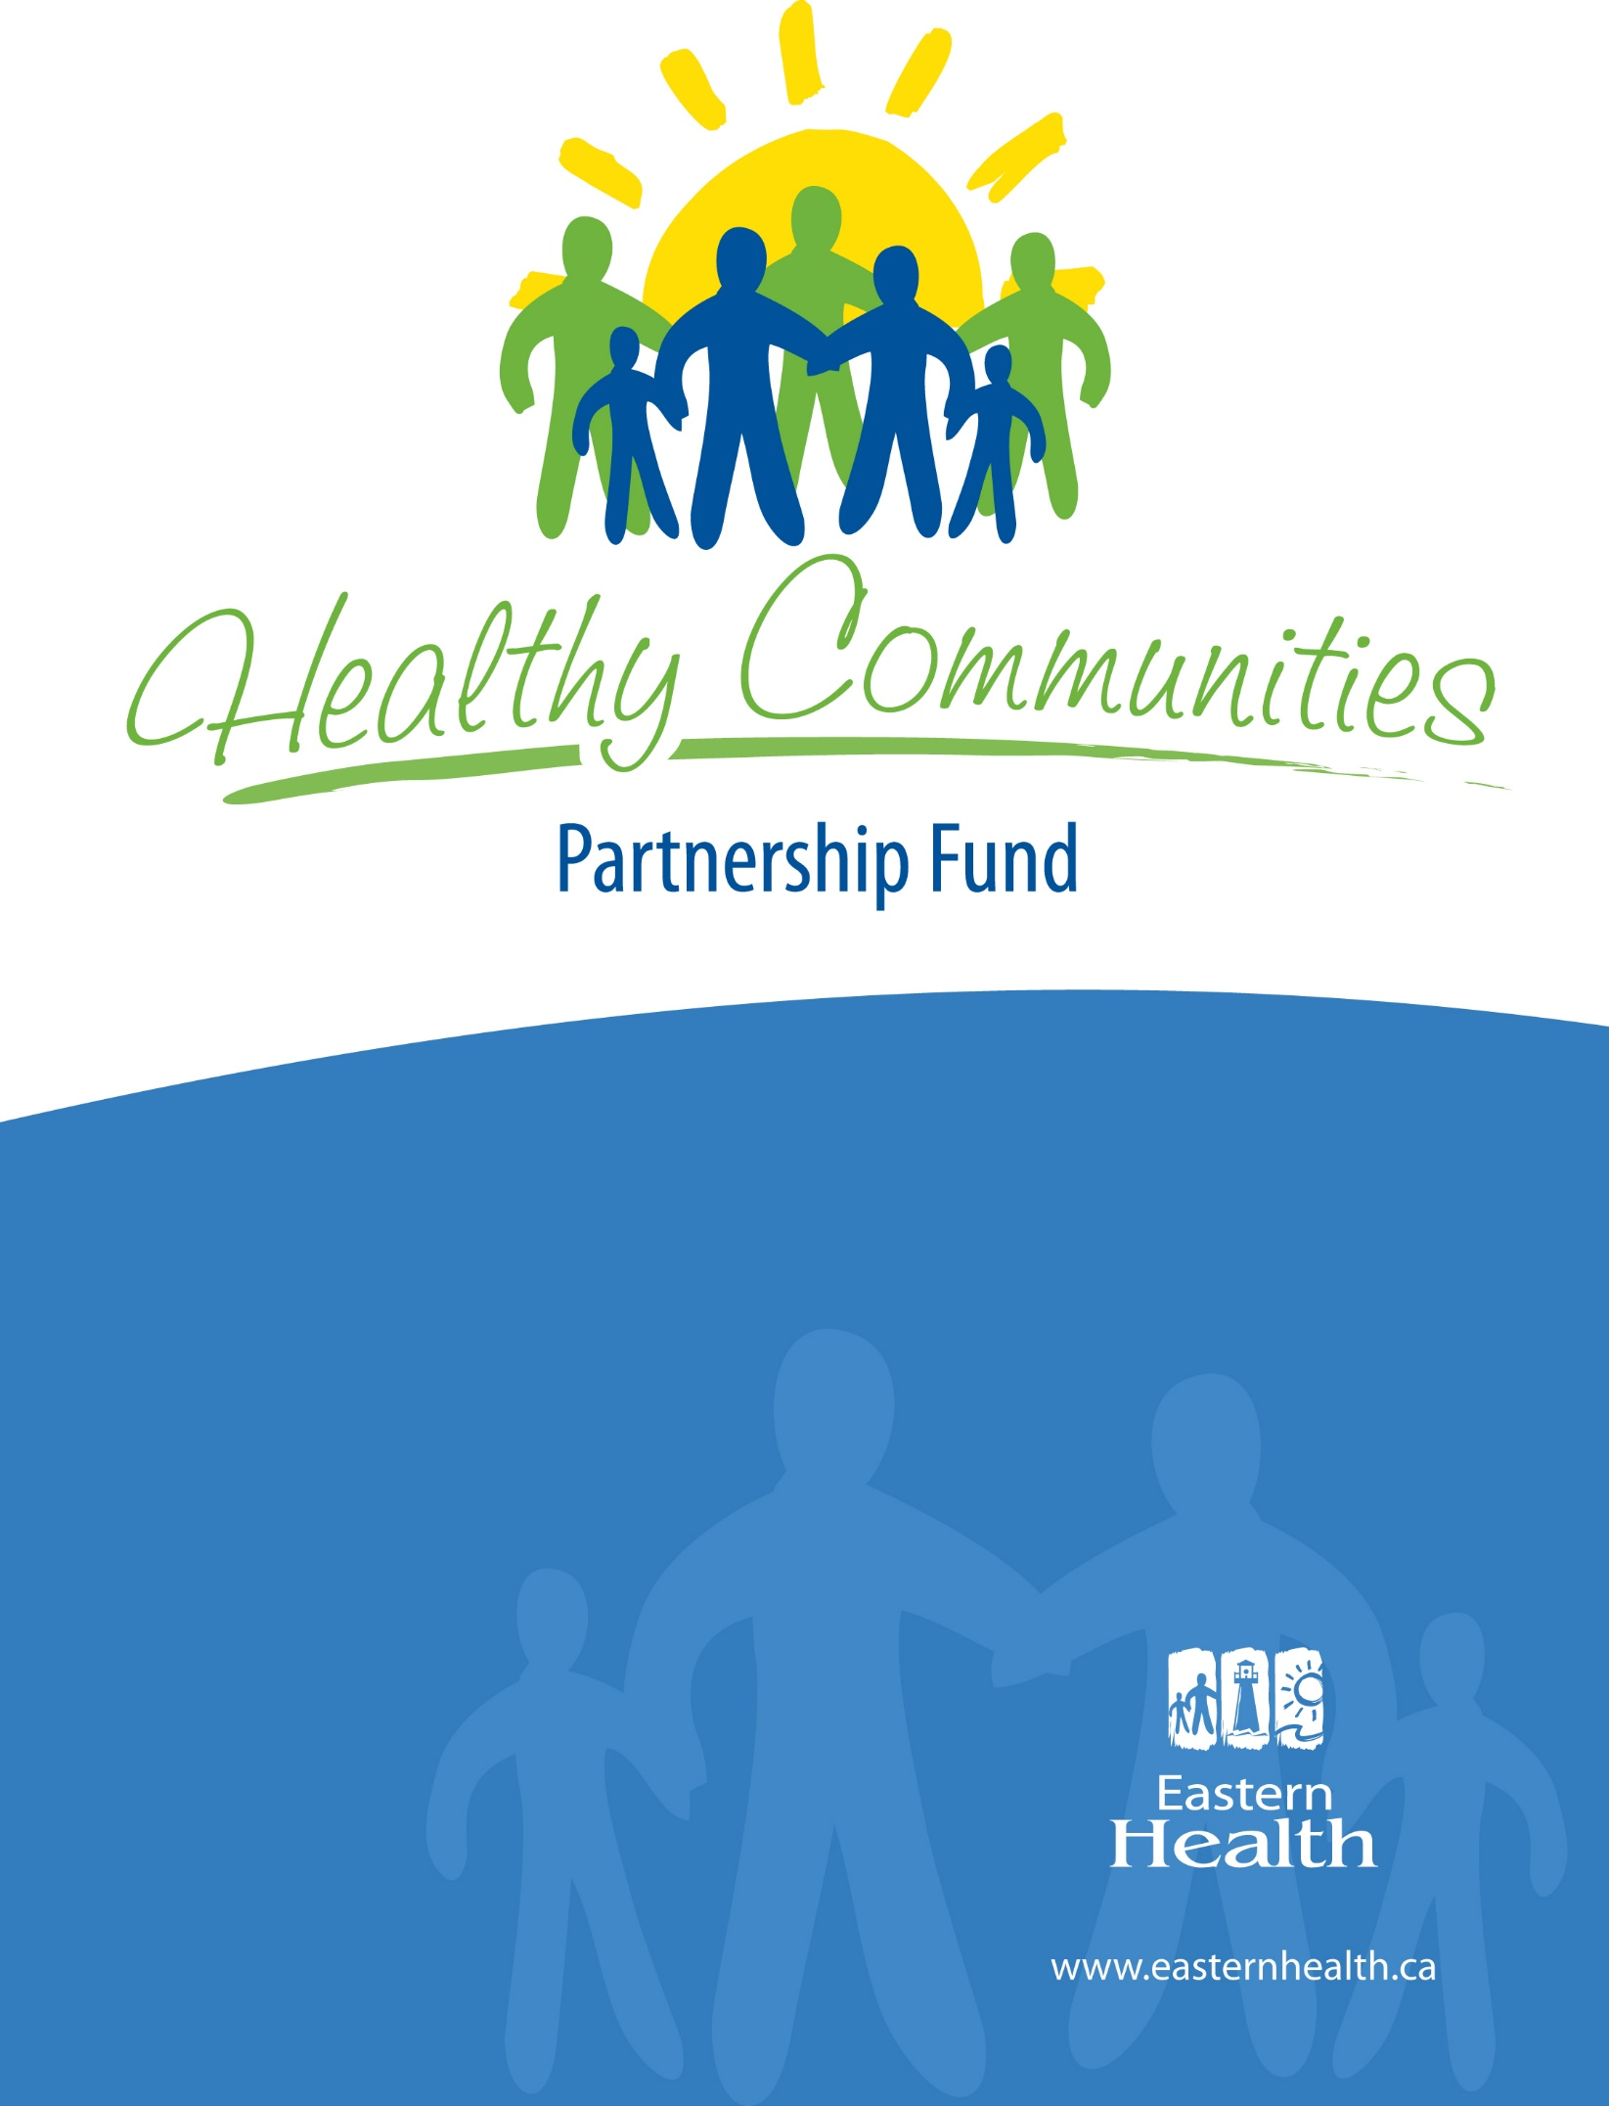
Eastern Health has a vision of Healthy People, Healthy Communities. Our vision is rooted in the recognition that as an organization, our focus is upon both individual and community approaches to health. Healthy communities enhance the prospect for individual health, and when individuals are healthy, communities are healthy. Eastern Health is committed to working with our partners toward our vision of Healthy People, Healthy Communities.
2021 Grant Guidelines

What is the Healthy Communities Partnership Fund?
_____________________________________________________________________________________________________________________

Established by Eastern Health’s Board of Trustees, the Healthy Communities Partnership Fund enables local community groups and organizations to strengthen partnerships and foster the development of healthy communities by working collaboratively with Eastern Health.

Proposed projects should contribute to building a healthier community by:
- strengthening social support networks e.g. increasing resident’s access to other people and/or community resources;
- developing community connections and partnerships e.g. working with a new group;
- addressing a health and wellness need in the community e.g. physical activity opportunities for youth;
- creating supportive environments e.g. creating policy for healthier choices in community settings; and/or
- strengthening community action e.g. forming a community committee to address an issue.

Projects can be new or can build on existing projects with new activities or objectives to reach project goal/s.

The fund is structured around an idea-to-application process. With this concept, the potential applicant connects with a Healthy Communities Consultant to discuss their project ideas and to obtain the application form.

The purpose of the consultation process is to:
- assist applicants in understanding the purpose and basic eligibility requirements of the fund;
- assist applicants in developing a project based on community assets, needs and evidence;
- foster or strengthen partnerships with other community groups;
- foster or strengthen partnerships with Eastern Health;
- foster or strengthen the relationships between the Healthy Communities Consultants and applicants;
- enhance use of best-practices in project development.

What amount of funding is available?
_____________________________________________________________________________________________________________________

The Healthy Communities Partnership Fund is valued at $50,000, with individual grants available up to a maximum of $10,000.

Who can apply?
_____________________________________________________________________________________________________________________

Who can apply?

Funding is available for non-profit community based groups and organizations. An organization is considered not-for-profit if it meets all of the following conditions:

- It is organized and operates solely for not-for-profit purposes in the province.
- It does not make any of its income available for the personal benefit of any of its members or volunteers.

Applicants must serve the population within the geographic boundary of Eastern Health (from the St. John’s region west to Port Blandford, including all communities on the Avalon, Burin and Bonavista Peninsulas).

Who are not eligible to apply?

- Schools
- Foundations whose sole purpose is to raise and distribute funds
- Eastern Health programs
- Recipients of the 2019 Healthy Communities Partnership Fund. This is because recipients cannot receive funding for two consecutive grant rounds (Note: no funds were awarded in 2020)

What expenses are not eligible for funding?
_____________________________________________________________________________________________________________________

- Fundraising campaigns
- Core operating funds (e.g. light, heat, core organizational staff salaries)
- Capital costs (e.g. furniture, office equipment, building renovations)
- Out of province travel
- Direct provision of health care services
- Individual scholarship, bursaries
- Research-based projects/programs
- Conferences

What is Health?
_____________________________________________________________________________________________________________________

Health is more than the absence of illness. Health is determined by a number of different factors that all act together to affect our health. These factors include income, where we work, where we live, our support networks such as family and friends, personal health practices, childhood experiences, education and coping skills. These factors play a critical role in contributing to healthy people and healthy communities.

What is a Healthy Community?
_____________________________________________________________________________________________________________________

“A healthy community is one that is constantly creating and improving physical and social environments and expanding community resources, which allow people to support each other in performing all functions of life, and develop to their fullest potential.”

-World Health Organization

What do we mean by partnership?
_____________________________________________________________________________________________________________________

Partnerships are a close cooperation between two or more organizations/groups that have common interests, rights or responsibilities. Partnerships help communities to share knowledge and skills and to build capacity within the community. Partners should be separate from your group or organization. For example, a local 50+ group partners with a youth organization to develop a community garden.

Are applicants required to have project partners?
_____________________________________________________________________________________________________________________

Yes. In addition to your partnership with Eastern Health as the funder, applicants are required to have one or more organizations/groups working in partnership on the project.

Applicants must indicate how their project partner(s) will contribute to the project. A letter of support is not sufficient to demonstrate partnership.

Applications where Eastern Health is the only partner will not be considered for funding.

What is Eastern Health’s role as a partner?
_____________________________________________________________________________________________________________________

As a partner in your project, Eastern Health will provide funding and other supports through the Healthy Communities Consultants. These supports may include:
- reviewing and providing detailed feedback on the project proposal, design, implementation, evaluation;
- linking your group/organization to other Eastern Health resources/programs e.g.: Mental Health and Addictions, Primary Health Care, Public Health Nursing;
- connecting your group/organization to others in the community who may be able to assist with the project;
- meeting regularly and at any point during the project to see how the project is evolving, to discuss issues/concerns and offer support/guidance if needed;
- continued follow up with your group/organization post project if needed.

What information should be included on the Healthy Communities Partnership Fund application form? _____________________________________________________________________________________________________________________

An application form must be completed by those seeking funding through the Healthy Communities Partnership Fund. The application form can only be obtained from a Healthy Communities Consultant.

Applicants must include the following information:
Contact Information: This includes contact information for your organization/group.

Eligibility and Requirements: This includes information on eligibility of the applicant.

About your Organization/Group: This includes information about your organization/group such as your purpose, services or programs you provide and population that you serve.

Project Description: This includes project name, start and end date as well as:
- Project Summary: Prepare a brief summary (limit one page) of the project, outlining what is happening in your community that inspired the project, what the project is about and what you hope to accomplish. Describe how your activities contribute to one or more of the following:

- Strengthen social support networks.
- Develop community connections and partnerships.
- Address a health and wellness need in your community.
- Create supportive environments.
- Strengthen community action.

- Target Population: Who will benefit the most from this project?
- Project Goal: A goal is a general statement outlining what you want to accomplish. It identifies the issue and the desired outcome of your plan. If you compare it to a road map, the goal is the destination - where you want to end up.
Sample Goal:
- Seniors in Centertown will have less injury due to falls.
- Project Objectives: Objectives flow from your goals. You may have one or more objectives for each goal. Objectives are specific, measurable statements of the desired change(s) that a project intends to accomplish, by a given time, for a specific population. Clear project objectives are essential to guide the project work and evaluation.
Sample Objective:
- By March 2022, there will be less falls on ice by seniors.
- Project Activities: Activities are those things you do in order to meet each objective, and ultimately your goal.
Sample Activities:
  - Identify seniors who require assistance with snow clearing and ice control around their homes.
  - Identify youth and adult volunteers who can assist with snow clearing.

Partnership Information:
This includes contact information on your project partner(s) and how they will contribute to this project. E.g.: provide space in-kind, offer funding or other resources, assist with planning/implementation, etc.

Evaluation:
Outcomes of a project are the changes that happen during or at the end of a project. In this section you are asked to identify:
1. How will you assess or measure your project activities?
2. What outcomes (changes) do you expect to achieve at the end of your project?
Budget:
This includes information on costs for the project including funds requested from the Healthy Communities Partnership Fund, other funds and in-kind contributions.
Signatures:
This includes signatures from an authorized signing authority for the applicant organization/group as well as signature of partner organization(s).

What other things should you keep in mind when preparing your application?
_____________________________________________________________________________________________________________________

- Simple programs can be very effective.
- Try not to do too much.
- Accept that not everything will work but look for other options.
- More money is not always the answer.
- Ask…ask… and ask again for help and advice.
- Projects can help to improve the health of people in the community as well as bring the community together.

How do I apply?
_____________________________________________________________________________________________________________________

This fund is structured around an “idea to application” process. Contacting a Healthy Communities Consultant (HCC) is a requirement for application submission. Applicants who do not connect with a HCC will not be considered for funding.

Please ensure you:
- review the guidelines;
- contact the Healthy Communities Consultant in your region to:
  - obtain an application form, and
  - discuss the basic idea of your project; how it addresses health and wellness in your community as well as potential partnerships.

Who is the Healthy Communities Consultant in my region?

St. John’s and area:
Heather Powell
709-752-4912
Heather.powell@easternhealth.ca

Clarenville, Bonavista and Burin Peninsulas areas:
Tammy Greening
709-466-6316
Tammy.greening@easternhealth.ca

Trinity-Conception-Placentia areas:
Tracey Sharpe-Smith
709-945-6531
Tracey.sharpesmith@easternhealth.ca

NOTE: If you are unable to reach the consultant for your area, please contact another consultant.

What is the deadline to submit applications?
_____________________________________________________________________________________________________________________

An application form must be completed and submitted by 4:30 p.m. on October 27, 2021.

Incomplete or late applications will not be considered. Applications may be faxed, e-mailed or mailed by the deadline. Note: mailed applications must be postmarked prior to the deadline date.

Healthy Communities Partnership Fund
c/o Monica Vatcher
Eastern Health, 35 Tilley’s Road, Clarenville, NL, A5A 1Z4
Fax: (709) 466-6305
Email: monica.vatcher@easternhealth.ca

*Please do not contact Monica with questions regarding the application process. If you have any questions, please contact the Healthy Communities consultant for your area.

When will I know if my application has been successful? _____________________________________________________________________________________________________________________

Following the review, applicants will be notified by mail regarding the status of their application. The review can take up to 4-6 weeks to complete.

